**D15B/34** **Mikil Lalwani** **Advance DevOps**

**Experiment No. 01**

**Aim:**

To understand the benefits of Cloud Infrastructure and Setup AWS Cloud9 IDE, Launch AWS Cloud9 IDE, and Perform Collaboration Demonstration.

**Theory:**

**What is AWS Cloud9?**

AWS Cloud9 is a cloud-based integrated development environment (IDE) that lets you write, run, and debug your code with just a browser. It includes a code editor, debugger, and terminal. Cloud9 comes prepackaged with essential tools for popular programming languages, including JavaScript, Python, PHP,and more, so you don’t need to install files or configure your development machine to start new projects. Since your Cloud9 IDE is cloud-based, you can work on your projects from your office, home, or anywhere using an internet-connected machine. Cloud9 also provides a seamless experience for developing serverless applications enabling you to easily define resources, debug, and switch between local and remote execution of serverless applications. With Cloud9, you can quickly share your development environment with your team, enabling you to pair programs and track each other's inputs in real-time.

**How does AWS Cloud9 work?**

The following diagram shows a high-level overview of how AWS Cloud9 works.

From the diagram (starting at the bottom), you use the AWS Cloud9 IDE, running in a web browser on your local computer, to interact with your AWS Cloud9 environment. A computing resource (for example, an Amazon EC2 instance or your own server) connects to that environment. Finally, your work is stored in an AWS CodeCommit repository or other types of remote repository.

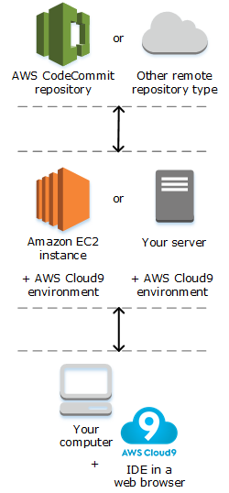

**What can I do with AWS Cloud9?**

With AWS Cloud9, you can code, build, run, test, debug, and release software in many exciting scenarios and variations.

**Benefits:**

* Code with just a browser
* Code together in real time
* Build serverless applications with ease
* Direct terminal access to AWS
* Start new projects quickly

**Steps:**

1. Login with your AWS account.

2. Navigate to Cloud9 service from the developer tools section.

3. Click on “Create Environment”.

4. Provide the name for the environment (WebAppIDE) and click on next.

5. Keep all the default settings.

6. Review the Environment name and Settings and click on Create Environment.

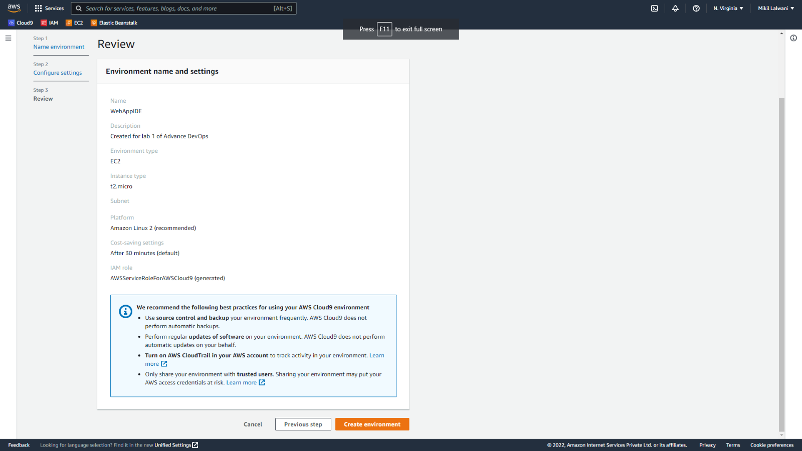

7. Open IAM Identity and Access Management in order to Add a user in another tab.

8. Add the user and provide a manual password if you want and click on the next permission tab.

9. Click on Create group.

10. Provide a group name and click on create a group. After that group is created click on next if u want to provide a tag else click on Review for user settings and click on create a user.

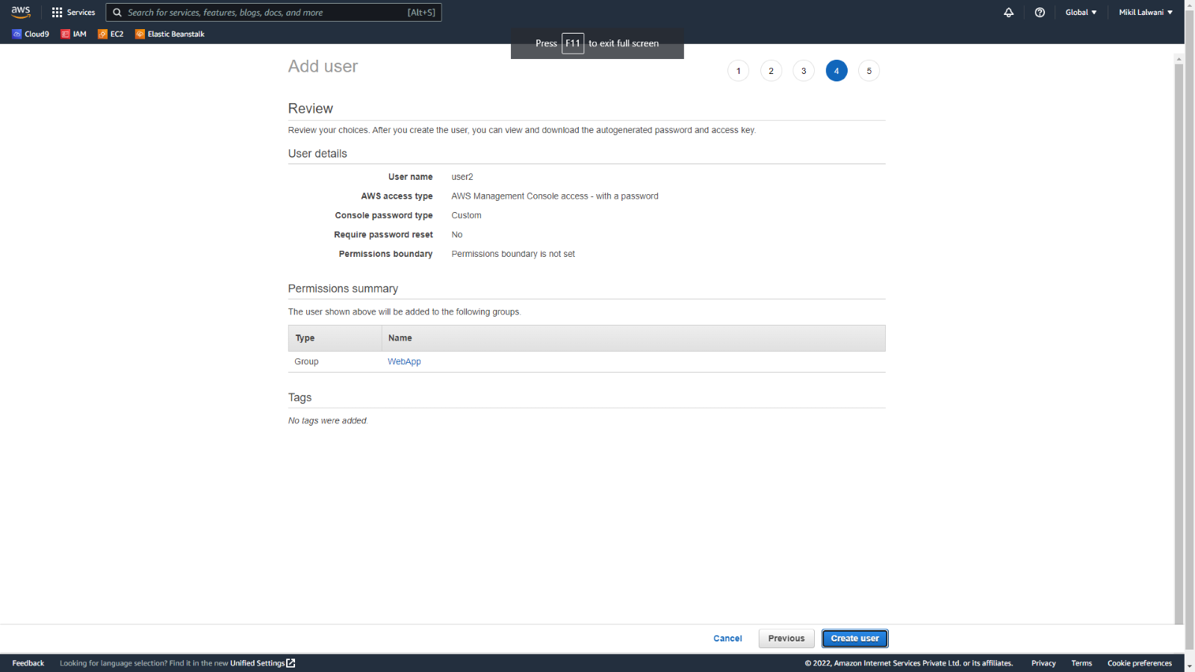

11. Now close that window and navigate to user Groups from the left pane in IAM.

12. Click on your group name which you have created and navigate to the permission tab.

13. Now click on Add permission and select Attach Policy. After that search for Cloud9 related policy and select Awscloud9EnviornmentMember policy and add it.

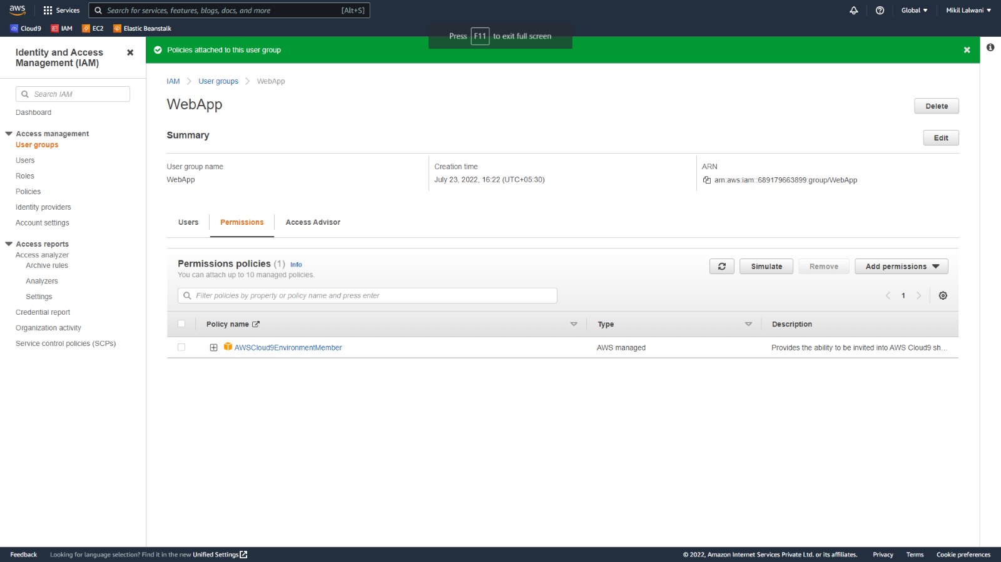

14. Now we move towards our cloud9 IDE Environment tab it shows.

15. If you check at the bottom side Cloud9 IDE also gives you AWS CLI for command operations: as we here checked git version, I AM user details, and so on.

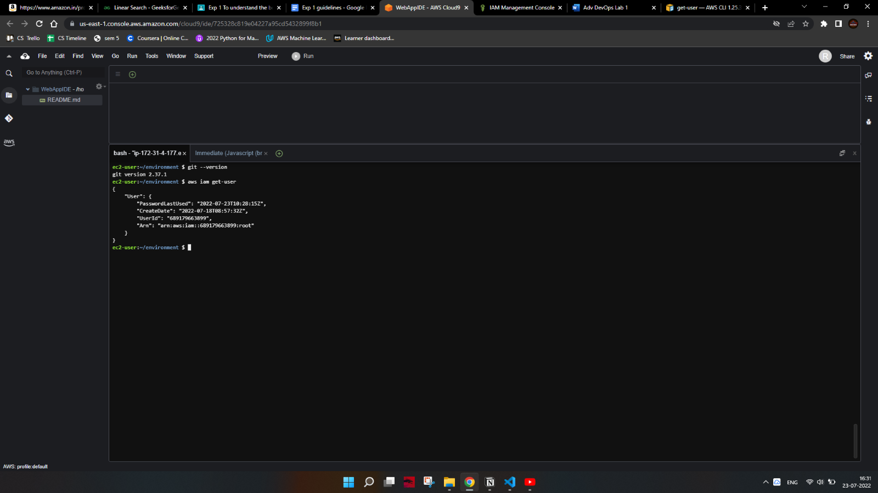

16. Now we will set up a collaborative environment Click on File you can create a new file or choose from a template, here m opting Html file to collaborate.

17. Edit the Html file and save it.

18. Now in order to share this file to collaborate with other members of your team click on the Share option on Right Pane and the username which you created in IAM before into Invite members and enable permission as RW (Read and Write) and click on Done. Click OK for the Security warning.

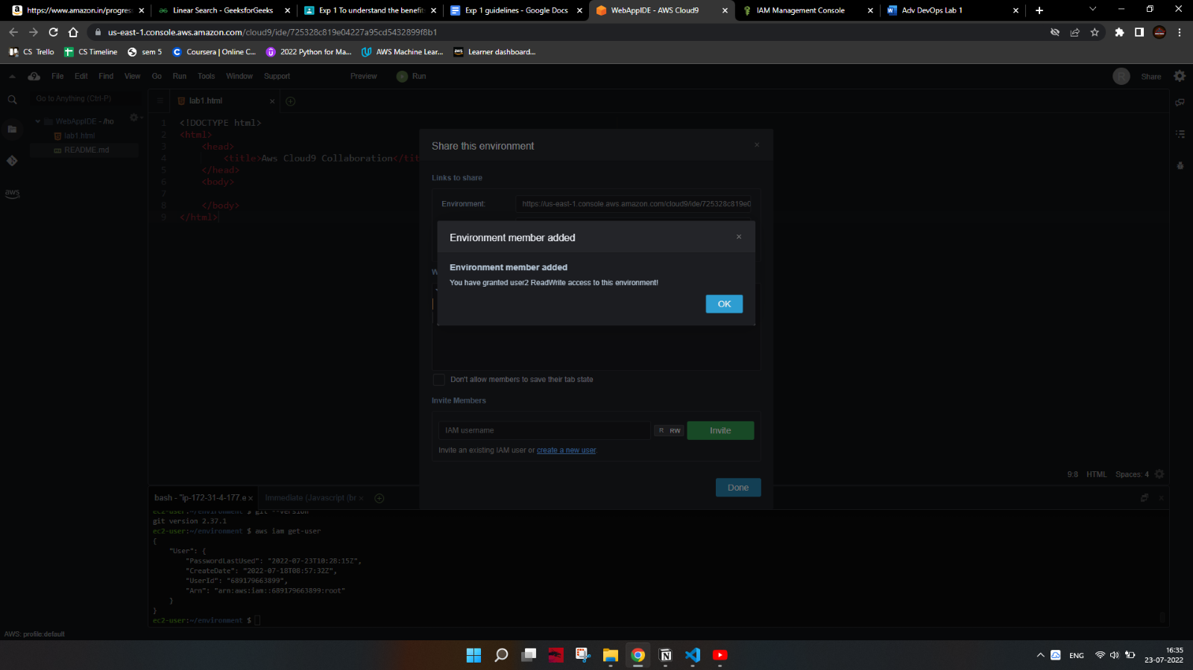

19. Now Open your Browsers Incognito Window and log in with IAM user which you configured before.

20. After Successful login with IAM users open Cloud9 service from dashboard services and click on share with your environment to collaborate.

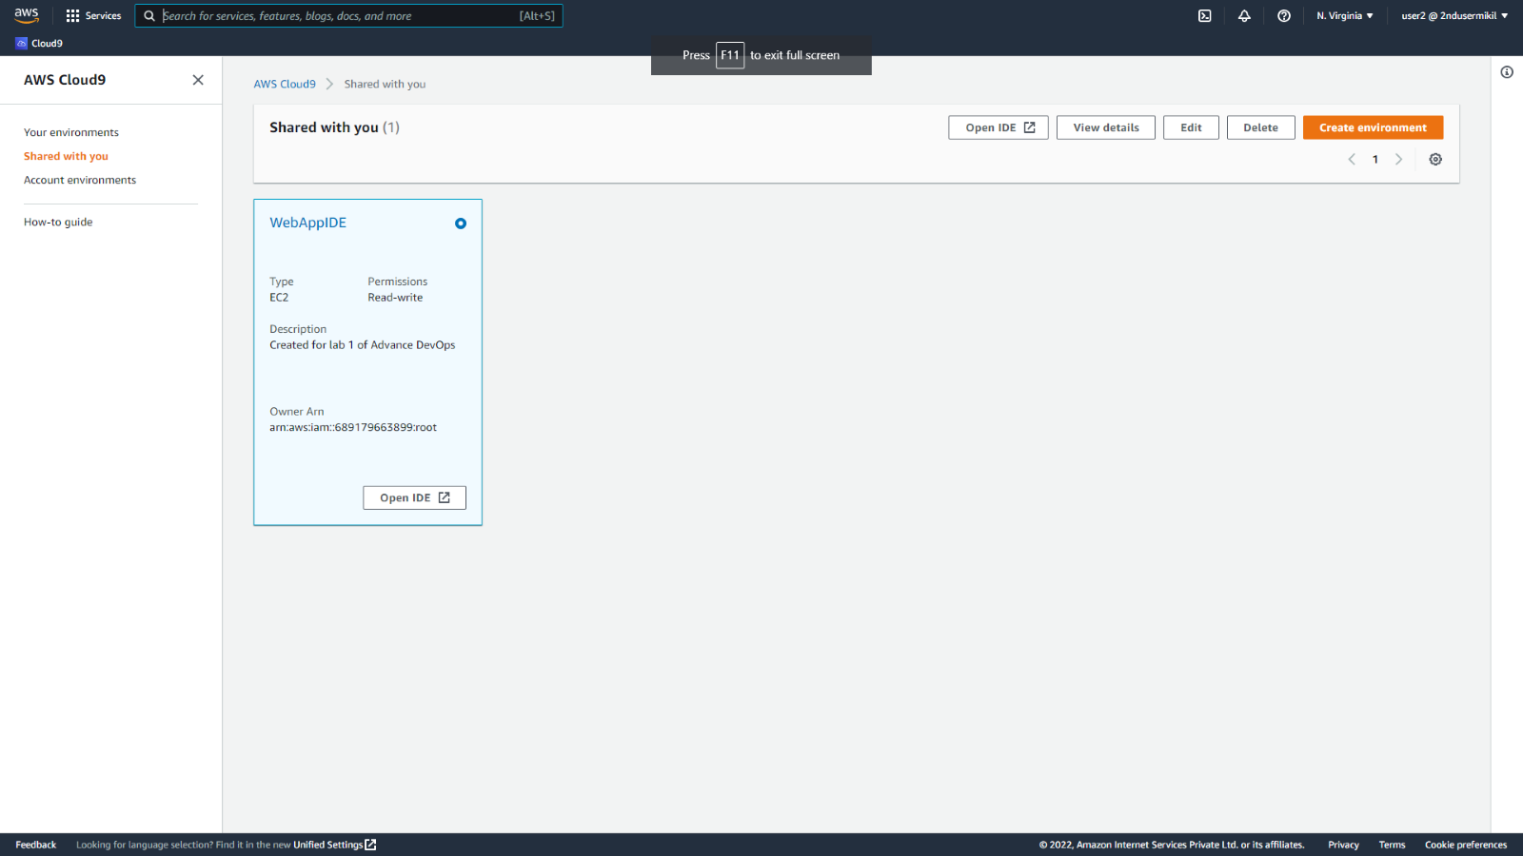

21. You can also explore settings where you can update permissions of your teammates from RW to R only or you can remove users too.

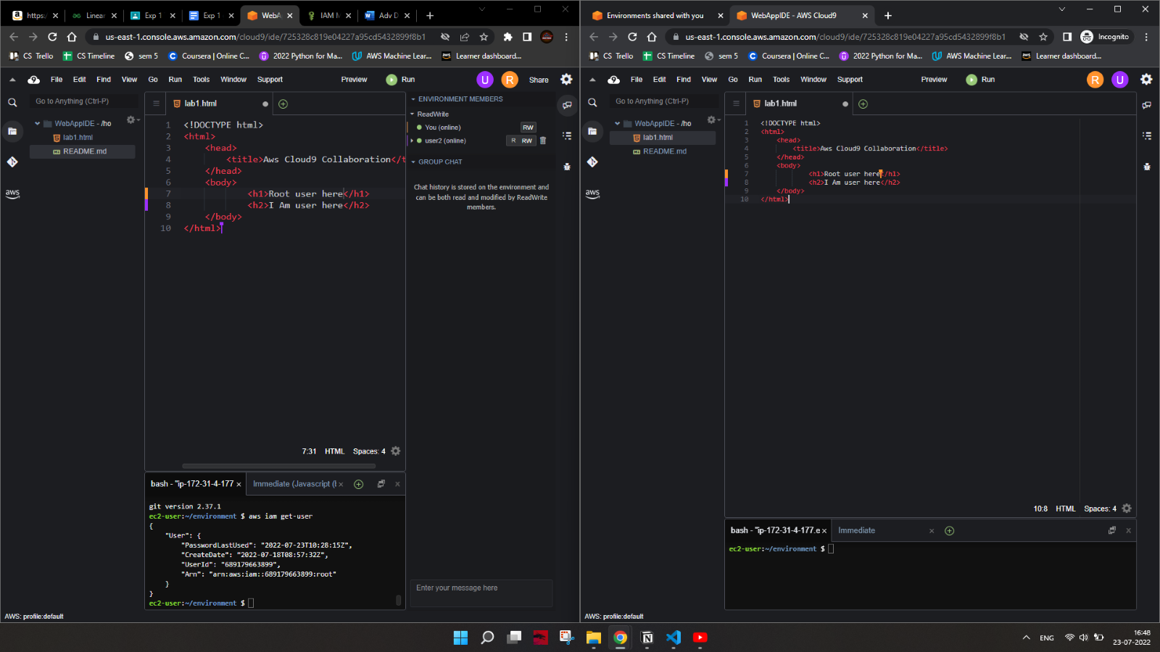

**Conclusion-**

Thus, we successfully understood the benefits of cloud infrastructure and setup and launched AWS Cloud9 IDE, and also performed a collaboration demonstration.